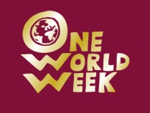
1000 Paper Cranes
The Story of Sadako Sasaki
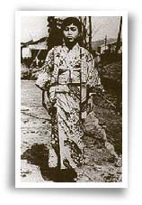
Sadako at age 12
Sadako was two years old when the atomic bomb was dropped on Hiroshima. She was two kilometres away from where the bomb exploded. Most of Sadako's neighbours died, but Sadako wasn't injured at all, at least not in any way people could see.
Up until the time Sadako was in the seventh grade (1955) she was a normal, happy girl. However, one day after an important relay race that she helped her team win, she felt extremely tired and dizzy. After a while the dizziness went away leaving Sadako to think that it was only the exertion from running the race that made her tired and dizzy. But her tranquillity did not last. Soon after her first encounter with extreme fatigue and dizziness, she experienced more incidents of the same.
One day Sadako became so dizzy that she fell down and couldn’t get up. Her school-mates noticed and informed the teacher. Later Sadako’s parents took her to the Red Cross Hospital to see what was wrong with her. Sadako found out that she had leukaemia, a kind of blood cancer. Nobody could believe it.
At that time they called leukaemia the “A-bomb disease”. Almost everyone who got this disease died, and Sadako was very scared. She wanted to go back to school, but she had to stay in the hospital where she cried and cried.
Shortly thereafter, her best friend, Chizuko, came to visit her. Chizuko brought some origami (folding paper). She told Sadako of a legend. She explained that the crane, a sacred bird in Japan, lives for a hundred years, and if a sick person folds 1,000 paper cranes, then that person would soon get well. After hearing the legend, Sadako decided to fold 1,000 cranes in the hope that she would get well again.
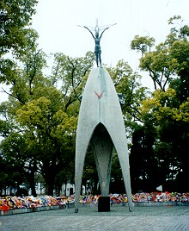
Sadako's family worried about her a lot. They often came to visit her in hospital to talk to her and to help her fold cranes. After she folded 500 cranes she felt better and the doctors said she could go home for a short time, but by the end of the first week back home the dizziness and fatigue returned and she had to go back to the hospital.
Sadako kept folding cranes even though she was in great pain. Even during these times of great pain she tried to be cheerful and hopeful. Not long afterwards, with her family standing by her bed, Sadako went to sleep peacefully, never to wake up again. She had folded a total of 644 paper cranes.
Every one was very sad. Thirty-nine of Sadako's classmates felt saddened by the loss of their close friend and decided to form a paper crane club to honour her. Word spread quickly. Students from 3,100 schools and from 9 foreign countries gave money to the cause. On May 5, 1958, almost 3 years after Sadako died, enough money was collected to build a monument in her honour. It is now known as the Children's Peace Monument, and is located in the centre of Hiroshima Peace Park, close to the spot where the atomic bomb was dropped.
Many of the children who helped make the Children's monument a reality participated in the ceremony. Three students, including Sadako's younger brother Eiji Sasaki pulled the red and white tape off the statue to symbolize its completion, while Beethoven's Seventh Symphony was played. The little bell, contributed by Dr. Yukawa, inscribed with "A Thousand Paper Cranes" on the front and "Peace on Earth and in Heaven" on the back, rang out and the sound carried as far as the A-bomb Dome and the Memorial Cenotaph.
Children from all over the world still send folded paper cranes to be placed beneath Sadako’s statue. In so doing, they make the same wish which is engraved on the base of the statue:
"This is our cry; this is our prayer, Peace in the world".
Copyright © 1998–2010 by Hiroshima International School

